The Next Horizon for Db2: Redefining Databases with Agentic Intelligence
By Ashok Kumar, Krishna Guntuka, David Kalmuk, Satya Krishnaswamy

Traditional database management has reached a tipping point. As data volumes surge and systems grow increasingly complex, administrators face mounting challenges from unpredictable query performance and unplanned downtime to the difficulty of scaling operations without compromising reliability. Manual oversight and reactive AI assistants that respond only when prompted are no longer enough to keep pace.
From Breaking Point to Breakthrough: The Autonomous Database
Enter Agentic AI - autonomous, intelligent agents designed not just to assist with database operations, but to actively manage, optimize, and adapt them in real time. These systems go beyond simple monitoring. They continuously analyze database health, anticipate issues like storage fragmentation or resource bottlenecks before they escalate, select the right tools whether query optimization, an automated failover mechanism, or a table reorganization, and adjust their approach based on outcomes. The result: databases that stay efficient, secure, and resilient without constant human intervention.
Understanding Agentic AI
Agentic AI refers to systems that operate with a degree of autonomy capable of perceiving their environment, making decisions, and taking actions in pursuit of specific goals. Unlike traditional AI, which waits for an explicit prompt and returns a single output, agentic AI can assess a situation, formulate a multi-step plan, and execute tasks, often in parallel, refining its strategy as conditions change.
In a database context, this means an agentic system does not just flag a slow query and wait for a DBA to act. It identifies the root cause, evaluates potential fixes, applies the most appropriate one, and monitors whether the fix holds, all without being explicitly told to do so.

Agentic AI System Architecture
Agentic AI is not a single technology; it is a design approach that gives AI systems greater independence than traditional models. While implementations vary, most agentic architectures share a few core building blocks. Multiple large language models communicate through structured prompts, each handling a specific responsibility, one might focus on planning, another on tool selection, and another on evaluating results. These models access external tools and data sources, read and write to databases, and maintain state across interactions through memory and context management. Crucially, they operate within planning loops: assess the current state, decide on an action, execute it, observe the outcome, and iterate. This makes the system behave less like a single model responding to a prompt and more like a network of collaborating agents working toward a shared objective.
Agentic AI in the IBM Db2 Genius Hub
Do you know what the life of an enterprise DBA really looks like? In a typical large organization, over 20 DBAs each spend nearly half their time monitoring systems, tuning queries, maintaining performance, and managing recovery tasks. That’s thousands of hours poured into repetitive operations that are ripe for optimization.
Now imagine reclaiming 35% of that time because that’s exactly what our agentic solution delivers. Rather than relying on hardcoded functions and fixed paths, our AI agents autonomously determine the optimal tools and parameters in real time, adapting their behavior to the unique demands of each problem. Designed to act as an intelligent co-pilot, the system learns the environment, pinpoints bottlenecks, and surfaces actionable insights.
The result? A fundamental shift in how DBAs operate. They’re no longer confined to firefighting and routine maintenance -- instead, they evolve into strategic enablers of innovation, supported by AI co-pilots that autonomously handle the operational load. These agents continuously learn, adapt, and optimize, freeing up time, reducing risk, and unlocking new possibilities for data-driven transformation. Enterprises don’t just gain efficiency -- they gain agility, resilience, and deeper insight. DBAs become architects of performance, stewards of data intelligence, and catalysts for business growth.

Db2 Genius Hub sets a clear direction toward autonomous database operations, while keeping teams in control. Today, at launch, it operates as a human-in-the-loop system, where execution is designed for explicit approval and well-bounded automation. As we advance Db2 Genius Hub, the console’s capabilities will expand autonomous operation where it is safe and governed, enabling teams to adopt autonomy at their own pace while maintaining transparency and control across production environments.
Architecture
Db2 Genius Hub is a web-based console that helps you understand, govern, and optimize your fleet of IBM Db2 databases. It provides intelligent recommendations, insights into database usage, and tools for automating database management and performance tuning.
The Agentic AI Database Assistant is built on top of LangGraph, which provides a framework for orchestrating multi-agent workflows through stateful, graph-based execution. The Db2 Genius Hub Database Assistant provides a chat-based interface which in turn invokes the LangGraph-powered agents. Depending on the use case, the tools retrieve metrics from multiple sources: the Vector Store containing ingested Db2 knowledge assets, the Db2 repository database for historical telemetry data, and the live database instance for real-time monitoring in an agentic manner. This multi-agentic system leverages IBM Granite models for inference for fully air gapped environments and Claude models for cloud inferencing, enabling intelligent decision-making and contextual responses.

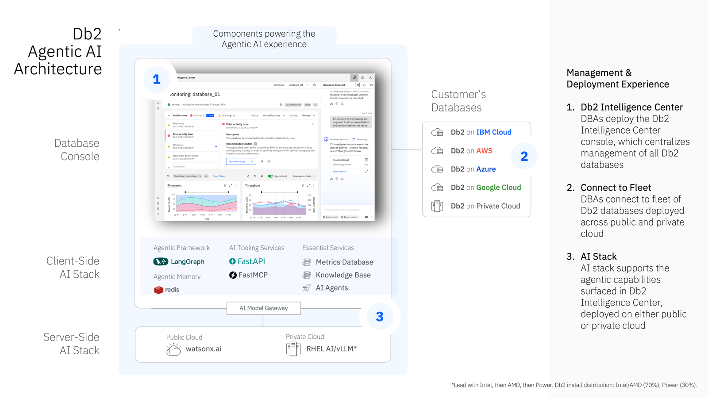

Overall Db2 Genius Hub Agentic Workflows and Agentic Loops
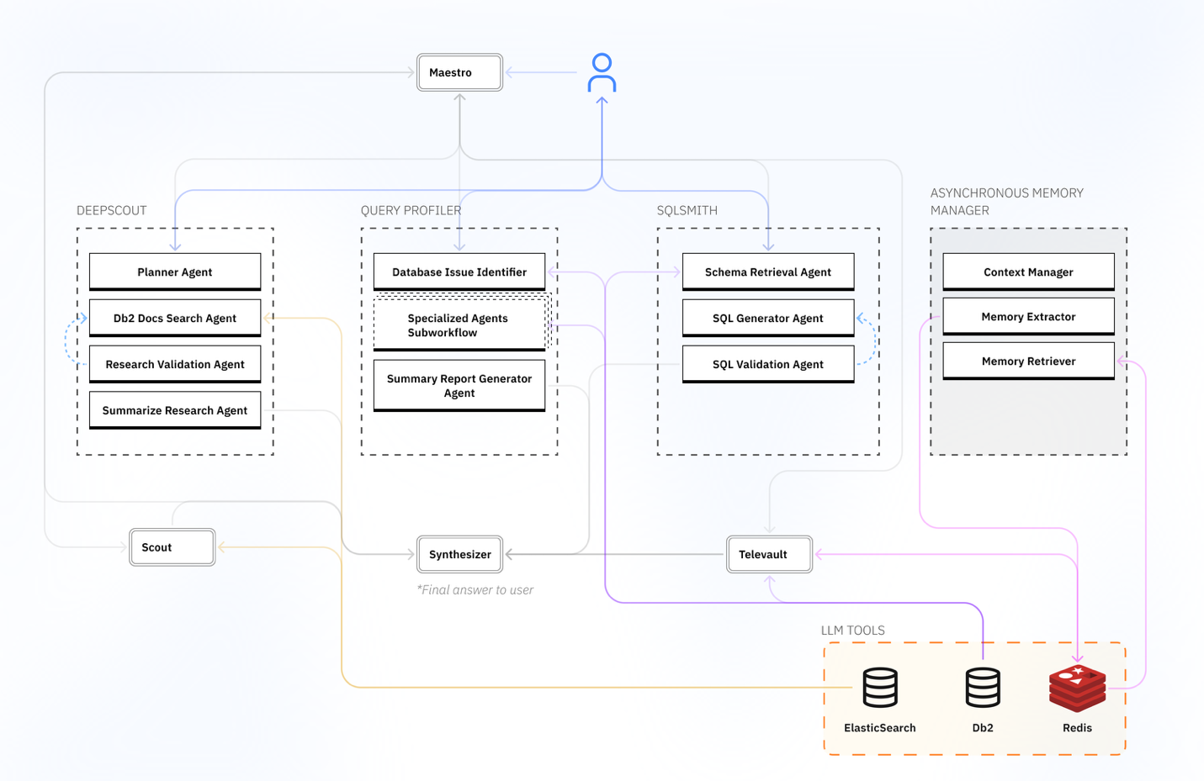
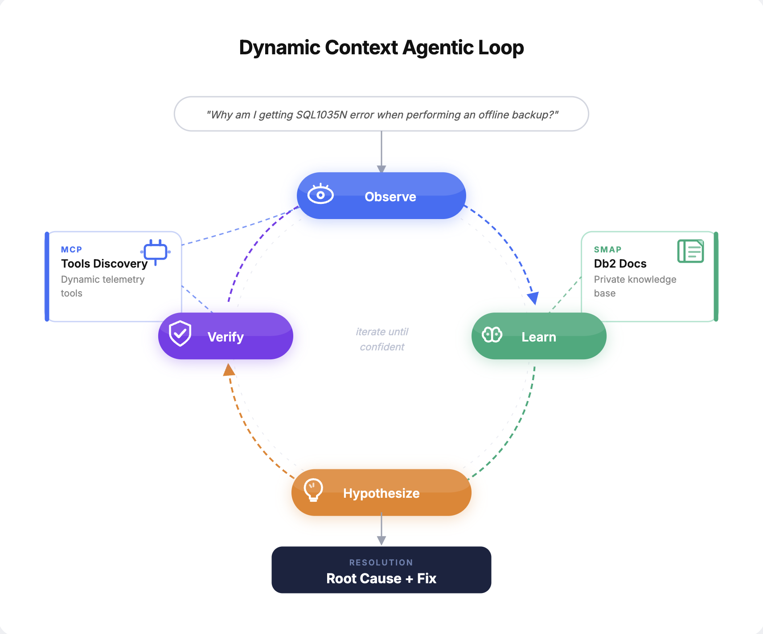

The multi-agent system architecture follows a hybrid execution model that combines a dynamic context agentic loop with proprietary expert workflows. At its core, a coordinator agent receives incoming requests and routes them to specialized agents and domain experts for tasks like SQL generation or performance analysis, and tool-using agents that interact with databases, APIs, and knowledge bases. For open-ended or unpredictable problems, the system enters a dynamic agentic loop where each iteration reassesses the current context and dynamically discovers which tools are available and relevant before deciding on the next action, meaning the agent adapts its strategy in real time as new information emerges. For well-understood, repeatable tasks where predictability and auditability matter most, such as compliance checks, data validation, or critical business logic, the system delegates to predetermined deterministic workflows with fixed execution paths. Multiple agents can operate concurrently across both modes, executing parallel queries, API calls, and search operations to reduce latency. This hybrid approach gives the system the adaptability of agentic reasoning where flexibility is needed while maintaining the reliability and traceability of deterministic pipelines where consistency is non-negotiable, making it function as a network of collaborating experts rather than a single isolated AI.​​​​​​​​​​​​​​​​
Db2 Agentic AI - Your Key to 10x Productivity
When it comes to managing and optimizing Db2, there’s a lot going on behind the scenes. From diagnosing performance bottlenecks to helping you explore your data, Db2’s Agentic AI capabilities work like a team of specialized experts, each focused on a specific challenge.
The Agentic AI Database Assistant is purpose-built around three core capabilities: agentic maintenance, where agents autonomously handle routine operational tasks like performance tuning, backup management, and system health checks; agentic healing, where the system detects anomalies and self-corrects issues such as resource contention, failed processes, and configuration drift before they escalate into outages; and agentic responses, where intelligent agents deliver real-time, context-aware answers to DBA queries by dynamically reasoning over live metrics, documentation, and historical patterns. Together, these pillars transform database management from a reactive discipline into a proactive, self-sustaining operation.​​​​​​​​​​​​​​​​
Embedded YouTube Demo: https://youtu.be/Ygz2O3a9SGA
Future (Vision) ^{*1}
The long-term vision is to make Db2 a truly self-managing and self-optimizing database -evolving from a system you manage, to a system that actively partners with you. Imagine a future where:
- Self-Tuning Queries - Agents automatically rewrite poorly performing queries, optimize access paths, and recommend schema adjustments without waiting for manual DBA intervention.
- Workload-Aware Scaling - Db2 anticipates workload spikes (e.g., end-of-quarter reporting, seasonal demand) and automatically adjusts resources across on-prem and cloud deployments to maintain consistent performance.
- Cross-Db2 Migration Intelligence - Agents orchestrate seamless movement of data across Db2 environments, automatically validating integrity, performance, and compatibility along the way.
- Autonomous Incident Management - Agentic AI integrates into SRE workflows, detecting anomalies before they escalate, simulating potential fixes, and safely executing resolutions, all while generating a clear explanation trail for teams.
- Continuous Learning & Prediction - Agents learn from historical workloads, predict future bottlenecks, and preemptively recommend corrective actions to avoid downtime or regressions.
This is the horizon we are moving toward. Db2 not only solves problems as they happen, but anticipates and prevents them, operating as a self-evolving, intelligent database ecosystem.

*1: IBM’s statements regarding its plans, directions, and intent are subject to change or withdrawal without notice and at IBM’s sole discretion.

About the Authors
Ashok Kumar is a Program Director in Hybrid Data Management with 15+ years of experience leading Db2, BigSQL, and Data Virtualization across on-premises and cloud platforms. He is driving the modernization of Db2 with innovations such as the Db2 AI Optimizer, Vector Storage, and Agentic AI. Ashok has also contributed to open-source distributed engines like Presto/Prestissimo, which power IBM’s Wxd and Lakehouse solutions.
Krishna Guntuka is a Software Engineer with 8+ years of experience in development on various Db2 products, currently leading Agentic AI Development for Db2 Database Assistant, his work focuses on different parts of these products, helping to make them work better and more efficiently.
David Kalmuk is a Distinguished Engineer, Master Inventor and Chief Architect for Databases at IBM. David currently leads the overall technical strategy for Databases in the IBM Data Core Products group, including Agentic AI. His efforts span the Db2 family of products including Db2, Db2 Warehouse, Db2 pureScale, as well as Netezza.
Satya Krishnaswamy is Director for Hybrid Data Management Development and is responsible for driving the HDM strategy, development, and maintenance of software deliverables which contribute to the success of their software brand and/or overall software portfolio. He develops product strategy and product roll-out, makes investment decisions on new and existing software product features and functionality, support clients and client engagement teams and is also responsible for delivering defined business results such as growing revenue, increasing market share, reducing operational costs, and improving customer satisfaction as well as improving the climate of their organizations and building organizational capacity.

